Use Cases Description
UC7- Email Management

For

Meeting Room
Booking System
(MRBS)

Prepared by K15T1-Team11
Van Lang University
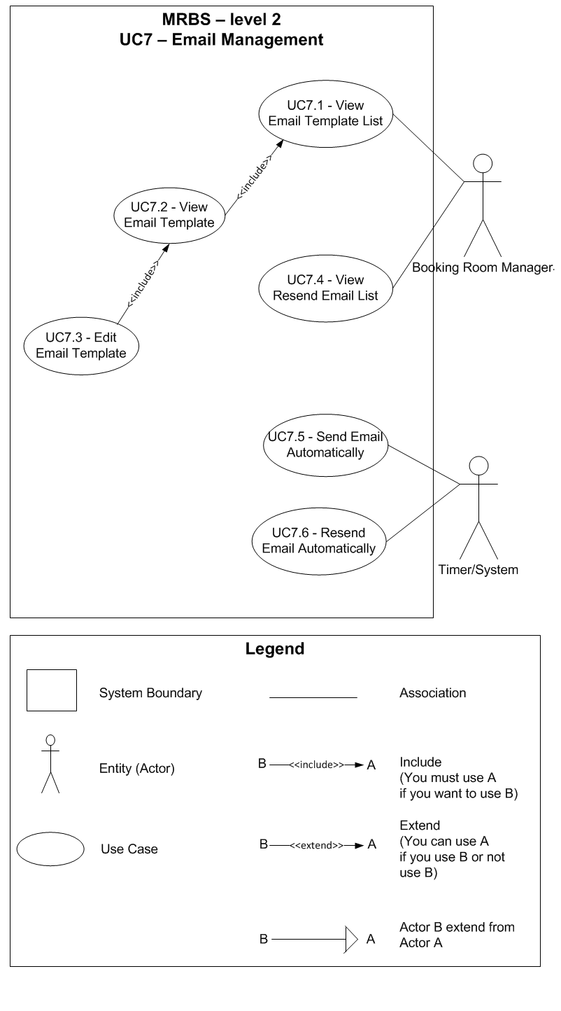
Table of Contents
UC7.1 – View Email Template List 4
UC7.2 – View Email Template 4
UC7.3 – Edit Email Template 5
UC7.4 – View Resend Email List 6
UC7.5 – Send Email Automatically 6
UC7.6 – Resend Email Automatically 7

UC7.1 – View Email Template List
ID | UC7.1
Name | View Email Template List
Author | Tam Do | Modify by
Date | 06/29/12 | Update
Actor | Booking Room Manager
Description | User can view list of email template
Precondition | User signed in system by Booking Room Manager’s account
Post condition: | Combobox show list of all email template
Main flow: | 1. User press “Danh mục”  2. User choose “Quản lý email”  3. System show new dialog “Quản lý email”  4. System load list of email template in database into combobox “Tên mẫu”  5. User press combobox “Tên mẫu”
Alternative flow:
Exception :
Includes:
Priority: | Normal
Business rules:
Mockup screen

UC7.2 – View Email Template
ID | UC7.2
Name | View Email Template
Author | Tam Do | Modify by
Date | 06/29/12 | Update
Actor | Booking Room Manager
Description | User can view a detail email template information
Precondition | User signed in system by Booking Room Manager’s account  User staying at “Quản lý phòng” form
Post condition: | System show a detail email template information that user choose
Main flow: | 1. User choose an email template from combobox “Tên mẫu”  2. System show a detail email template information that user choose
Alternative flow:
Exception :
Includes:
Priority: | Normal
Business rules:
Mockup screen

UC7.3 – Edit Email Template
ID | UC7.3
Name | Edit Email Template
Author | Tam Do | Modify by
Date | 06/29/12 | Update
Actor | Booking Room Manager
Description | User can edit an email template information
Precondition | User signed in system by Booking Room Manager’s account  User staying at “Quản lý email” form and viewing a detail email template information
Post condition: | System edit an email template information in database and show announcement
Main flow: | 1. User edit an email information that accept to edit (BR7.3.01)  2. User press “Lưu” button  3. System check the valid of information (BR7.3.02; BR7.3.03; BR7.3.04)  4. System save an email template information that edited in database  5. System show announcement that “Chỉnh sửa thông tin thành công” with “OK” button
Alternative flow:
Exception :
Includes:
Priority: | Normal
Business rules: | BR7.3.01 - User can edit field: “Tiêu đề”; “Nội dung”; “Áp dụng mẫu này”  BR7.3.02 – Required field not accept null: “Tiêu đề”; “Nội dung”  BR7.3.03 – “Tiêu đề” not accept more than 100 characters; accept characters and numeric, can use Vietnamese language  BR7.3.04 – “Nội dung” not accept more than 1000 characters; accept characters and numeric, can use Vietnamese language
Mockup screen

UC7.4 – View Resend Email List
ID | UC7.4
Name | View Resend Email List
Author | Tam Do | Modify by
Date | 06/29/12 | Update
Actor | Timer/System
Description | User can view list of waiting to resend email
Precondition | User signed in system by Booking Room Manager’s account
Post condition: | System shows all resend email
Main flow: | 1. User press “Danh mục”  2. User choose “Quản lý email”  3. System show new dialog “Quản lý email”  4. System show a list of resend email
Alternative flow:
Exception :
Includes:
Priority: | Low
Business rules:
Mockup screen

UC7.5 – Send Email Automatically
ID | UC7.5
Name | Send Email Automatically
Author | Tam Do | Modify by
Date | 06/29/12 | Update
Actor | Timer/System
Description | Timer will send email for borrower, new user automatically when Booking Room Manager use Booking Room Management function or Administrator use Create Account in User Management function
Precondition | Booking Room Manager or Administrator signed in system  Connect to internet  Booking Room Manager use Booking Room, Approve, Reject or Change booking room in Booking Room Management function  Or Administrator use Create Account in User Management function
Post condition: | Timer will send email automatically for borrower, new user
Main flow: | 1. Timer define what type of activities that Booking Room Manager or Administrator use  2. Timer will send email for borrower/new user follow what type of activities via internet
Alternative flow: | At step 2 of main flow (not connect internet):  3. Timer will add request to resend email for List of Resend Email
Exception :
Includes:
Priority: | High
Business rules:
Mockup screen

UC7.6 – Resend Email Automatically
ID | UC7.6
Name | ReSend Email Automatically
Author | Tam Do | Modify by
Date | 06/29/12 | Update
Actor | Timer/System
Description | Timer will resend email for borrower, new user automatically when System not connect to internet every 30 minutes or sign in
Precondition | Booking Room Manager or Administrator signed in system  Connect to internet  Have one request to resend email in list of resend email
Post condition: | Timer will resend email automatically for borrower, new user
Main flow: | 1. Timer will send email for borrower/new user follow what type of activities via internet
Alternative flow: | At step 1 of main flow (not connect internet):  2. Timer will add request to resend email for List of Resend Email again
Exception :
Includes:
Priority: | High
Business rules:
Mockup screen

